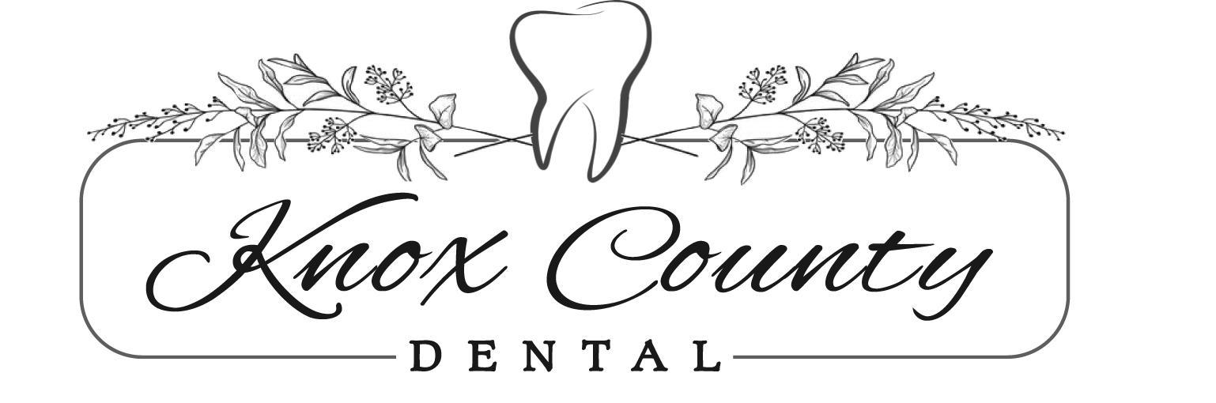
Financial Policy
- Please pay in full at the time of service unless payment arrangements have been made. We are happy to verify and file your insurance. The patient is responsible for any balance the insurance company does not cover.
- The Guardian who brings a minor child to our office is responsible for payment, in full, or the estimated patient portion for patients who have dental insurance.
- Payment Options - Cash, Check, Credit Card or Finance Company (Care Credit) - please ask for more information about Care Credit if you are interested
Consent: I have read, understood and agree to the above terms and conditions. I authorize my insurance company to pay my dental benefits directly to my dental office. I understand that responsibility for payment for dental services provided in this office for myself or my dependents is mine, due and payable at the time services are rendered.

________________________________________________________ ___________
Signature (Patient or Responsible Party) Date

Consent For Use and Disclosure of Health Information
Section A: Patient Giving Consent
*Patient’s Name:_______________________________________________________
Section B: To the Patient - Please Read the Following Statements Carefully
*Purpose of Consent: By signing this form, you will consent to our use and disclosure of your protected health information to carry out treatment, payment activities, and healthcare operations.
*Notice of Privacy Practices: You have the right to read our Notice of Privacy Practices before you decide whether to sign this Consent. Our Notice provides a description of our treatment, payment activities and healthcare operations, of the uses and disclosures, we may make of your protected health information, and of other important matters about your protected health information. A copy of our Notice accompanies this Consent. We encourage you to read it carefully and completely before signing this Consent.
*We reserve the right to change our privacy practices as described in our Notice of Privacy Practices. If we change our privacy practices, we will issue a revised Notice of Privacy Practices, which will contain the changes. Those changes may apply to any of your protected health information that we maintain.
*You may obtain a copy of our Notice of Privacy Practices, including any revisions of our Notice, at any time by contacting: Karie Holman / Aaron Golden
Telephone: (660) 397-2213 Fax: (660) 397-3929
Email: knoxcountydental.edina@gmail.com
Address: 107 N Main St, Edina, Mo 63537
*Right to Revoke: You will have the right to revoke this Consent at any time by giving us written notice of your revocation submitted to the Contact Person listed above. Please understand that revocation of this Consent will not affect any action we took in reliance on this Consent before we received your revocation, and that we may decline to treat you or to continue treating you if you revoke this Consent.

Signature
I, _____________________________________, have had full opportunity to read and consider the contents of this Consent form and your Notice of Privacy Practices. I understand that by signing this Consent form, I am giving my consent to your use and disclosure of my protected health information to carry out treatment, payment activities and health care operations.

Signature:________________________________________________ Date:________
If this Consent is signed by a personal representative on behalf of the patient, complete the following:
Personal Representative’s Name:___________________________________________
Relationship to Patient:___________________________________________________

