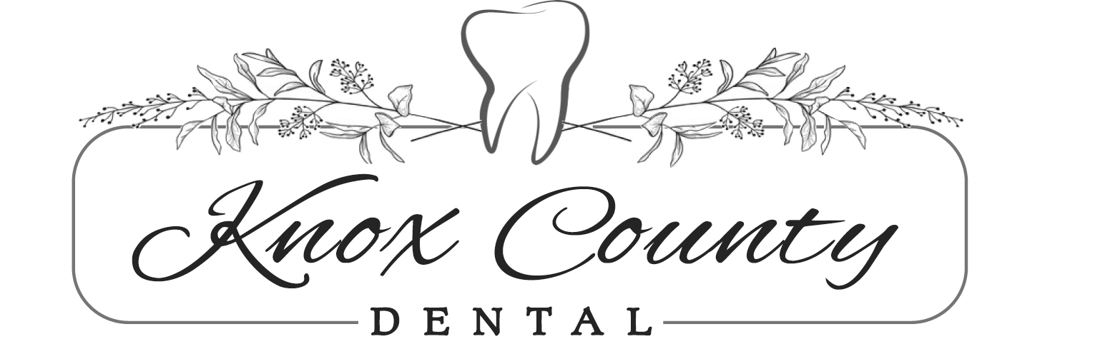

PHOTO / VIDEO RELEASE FORM

I hereby give Knox County Dental permission to use my likeness in photography / videography for publications, promotional purposes, on their website for advertisements, social medical platforms, for Knox County Dental’s purpose only. I understand that I will not receive compensation for the use of this likeness.

Patient’s Name:_________________________________________

Signature of Patient / Guardian:_____________________________

Signature of Witness:_____________________________________

Date:________________________________________________

